**REFACTORING LIST**

Team A

Between Build1 and Build 2 we did the following refactoring:

1. Call gameplay instance directly without assigning it to a variable to help with loadgame.

|  |  |
| --- | --- |
| Build 2 | There was no check on continents , if they are connected graphs while validating maps. |
| Build 2 | Added connected graph validation on continents before saving map. |
| Decision | Required |
| Solution | Perform DFS on individual continents in addition to the whole map. |

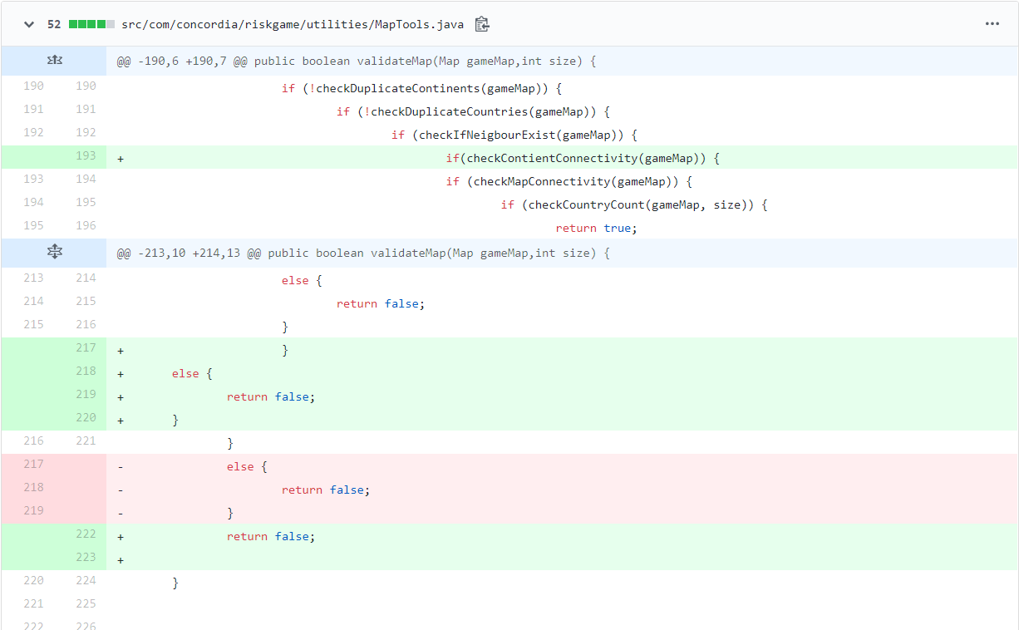

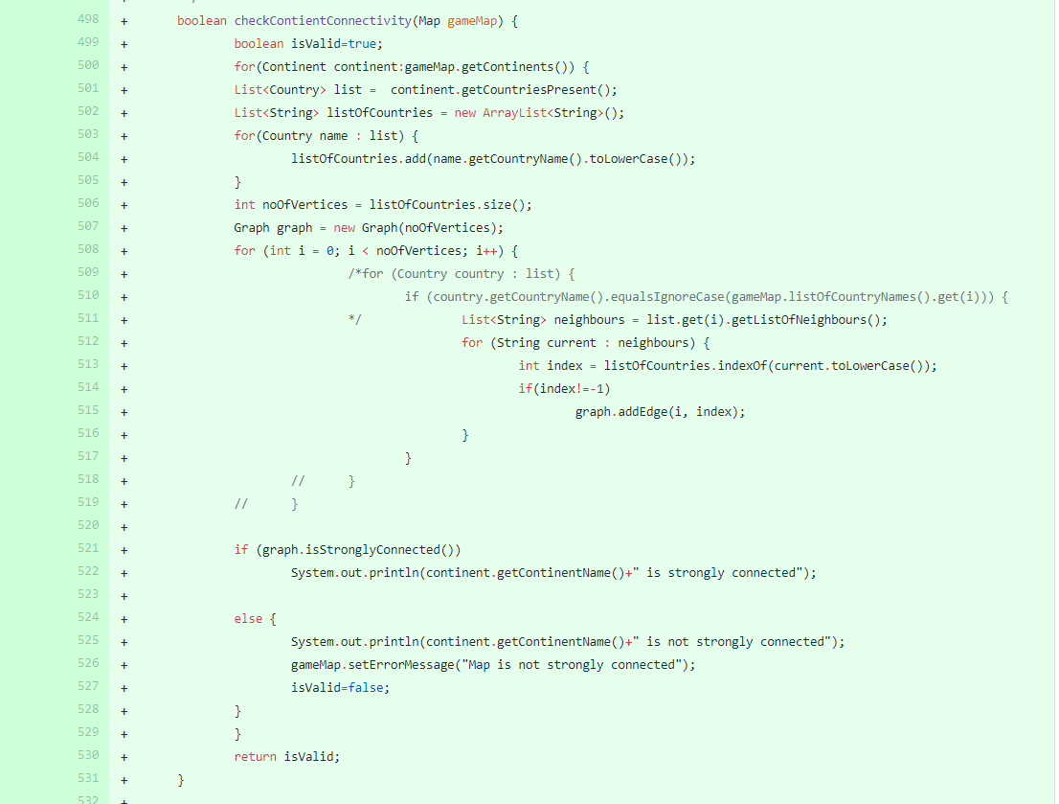

1. Randomize placeallArmies such that armies are more randomly distributed , in unpredictable fashion

|  |  |
| --- | --- |
| Build 1 | Final army distribution is predictable as armies are placed one by one on countries until player do not have any more armies. |
| Build 2 | Final army distribution is random. |
| Decision | Required |
| Solution | All countries are assigned an army and then the remaining armies are randomly assigned. |

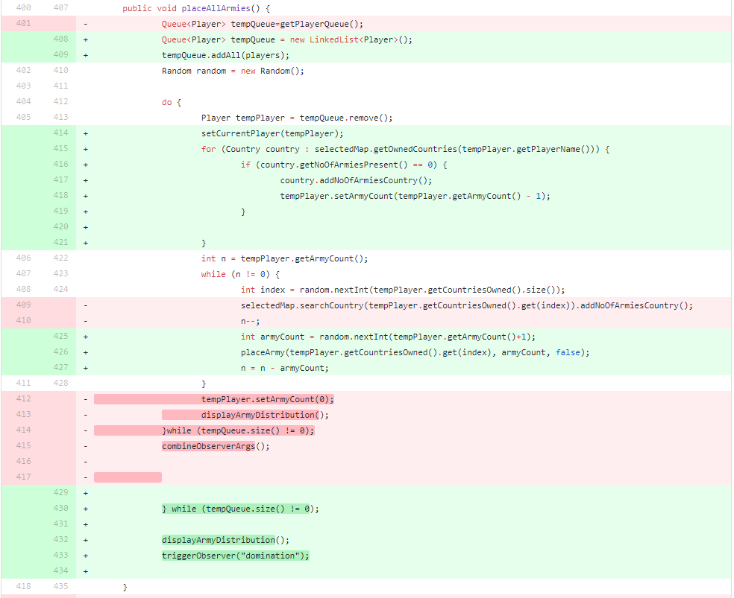

1. Prevent user from proceeding with the game if less than 2 players are added.

|  |  |
| --- | --- |
| Build 1 | User was able to populate countries and assign armies even with less than 2 players though an error message was thrown. |
| Build 2 | Minimum 2 players are mandatory to proceed with populating countries. |
| Decision | Required. |
| Solution | Add a check on input validation and prevent proceeding unless all checks are passed. |

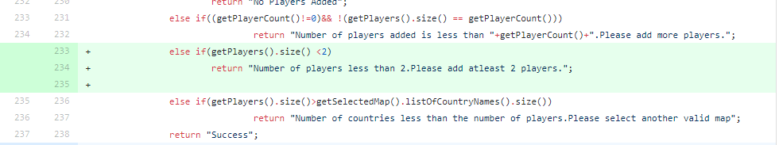

1. Set a default path for saving map.

|  |  |
| --- | --- |
| Build 1 | Maps were being saved in the current system directory where the IDE or Jar is invoked from. |
| Build 2 | Maps will be saved to a set location. |
| Decision | Required. |
| Solution | Create a variable in constants to set the map save location. |

